Keeping and staying safe

Year 4,5,6

|  |  |  |  |
| --- | --- | --- | --- |
| **Key objectives** | **Year 4** | **Year 5** | **Year 6** |
| 1. I can talk about the different ways I can keep myself and others safe. |  |  |  |
| 2. I can describe the term consequence. |  |  |  |
| 3. I can talk about differences between a risky choice and a safe choice. |  |  |  |
| 4. I understand that rules are put in place to keep me safe and I follow them carefully |  |  |  |
| 5. I can recognise peer pressure and know who I can speak to if I am struggling |  |  |  |
| 6. I understand that I am responsible for my own decisions. |  |  |  |
| 7. I can identify a range of different danger signs. |  |  |  |
| 8. I can talk about the impact on the community if there is a road traffic accident |  |  |  |

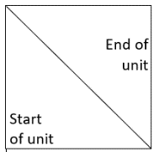

Key:

Keeping staying healthy

Year 4,5,6

|  |  |  |  |
| --- | --- | --- | --- |
| **Key objectives** | **Year 4** | **Year 5** | **Year 6** |
| 1. I can explain what is meant by a balanced diet and can plan a balanced meal |  |  |  |
| 2. I can talk about my healthy choices. |  |  |  |
| 3. I know how to look for the nutritional information on packaged food and use the information to make a healthy choice. |  |  |  |
| 4. I know that too much sugar, salt, saturated fats in food/drink can have negative consequences on our bodies as we get older. |  |  |  |
| 5. I can explain what it means to have a healthy lifestyle. |  |  |  |
| 6. I understand how advertising can influence what I choose to eat and drink |  |  |  |
| 7. I know that smoking cigarettes can negatively affect immediate and future health. |  |  |  |
| 8. I know that nicotine is a drug and it is a main ingredient in a cigarette. |  |  |  |
| 9. I can describe some of the physical and social consequences of smoking cigarettes |  |  |  |
| 10. I can give reasons why someone may feel pressured to smoke and I can give them advice against it. |  |  |  |
| 11. I can manage peer pressure around smoking because I am well  informed about the negative consequences |  |  |  |
| 12. I can understand the risks associated with drinking alcohol. |  |  |  |
| 13. I know how alcohol can negatively affect immediate and future health |  |  |  |
| 14. I have developed strategies to manage peer pressure and to help keep me safe |  |  |  |
| 15. I understand that rules and laws are put in place to keep me safe and I follow them carefully. |  |  |  |

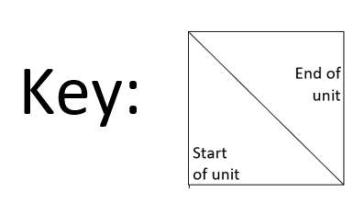

Being responsible

Year 4,5,6

|  |  |  |  |
| --- | --- | --- | --- |
| **Key objectives** | **Year 4** | **Year 5** | **Year 6** |
| 1. I know that it is important to behave responsibly. |  |  |  |
| 2. I understand the importance of following rules set for me at home. |  |  |  |
| 3. I know there are situations that will arise when being on time is very important |  |  |  |
| 4. I can describe sensible and responsible behaviour and know what this looks like. |  |  |  |
| 5. I can describe careless and irresponsible behaviour and know what this looks like |  |  |  |
| 6. I know that its responsible behaviour to speak out when I recognise that someone is being continually unkind. |  |  |  |
| 7. I can explain why it is important to look out for others. |  |  |  |
| 8. I know that it is important to set an example of appropriate behaviour and to stand up to those who do not behave in a responsible or appropriate way. |  |  |  |
| 9. I know that by making irresponsible choices, I put myself and others at risk and could create negative consequences. |  |  |  |
| 10. I understand that it is wrong to steal and that I should never steal from anyone |  |  |  |
| 11. I know that I should never take something that does not belong to me without the permission of the person it belongs to |  |  |  |
| 12. I know it is important to maintain a positive and trustworthy relationship with my friends and family |  |  |  |
| 13. I can explain what ‘consent’ means. |  |  |  |

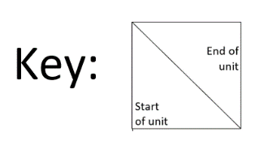

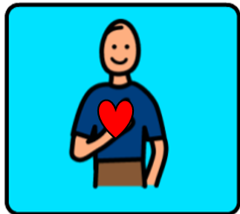

Feelings and emotions

Year 4,5,6

|  |  |  |  |
| --- | --- | --- | --- |
| **Key objectives** | **Year 4** | **Year 5** | **Year 6** |
| 1. I know that some feelings will make me feel good and happy while others might not feel so good. This is normal for everyone |  |  |  |
| 2. I can consider thoughts, feelings and emotions and I know the differences between them |  |  |  |
| 3. I can identify how to help others who feel upset, lonely or jealous. |  |  |  |
| 4. I know that my emotions might affect my behaviour and that my choices and actions can affect myself and others |  |  |  |
| 5. I know that some feelings will have an effect on my body - both pleasant and unpleasant. |  |  |  |
| 6. I can understand my feelings may show, even if I don’t say them out loud |  |  |  |
| 7. I know how to support someone who is feeling worried. |  |  |  |
| 8. I know who ask for help when I am feeling worried and know that I may feel better if I do so |  |  |  |
| 9. I can explain how feelings can be communicated with and without  words. |  |  |  |
| 10. I can identify how to reduce the feeling of worry |  |  |  |
| 11. I understand how I can manage the feeling of jealousy. |  |  |  |
| 12. I can describe how to positively manage the feeling of anger |  |  |  |





Computer safety

Year 4,5,6

|  |  |  |  |
| --- | --- | --- | --- |
| **Key objectives** | **Year 4** | **Year 5** | **Year 6** |
| 1. I can explain the term ‘online bullying’. |  |  |  |
| 2. I can explain some of the consequences of online bullying. |  |  |  |
| 3. I know and can name different types of online bullying |  |  |  |
| 4. I can talk about the feelings and emotions we can have if we have a negative online experience |  |  |  |
| 5. I can talk about some of the ways I could get help if I have a negative online experience |  |  |  |
| 6. I know the positive and negative consequences of sharing images online |  |  |  |
| 7. I have a set of rules I follow before I share an image to prevent negative consequences |  |  |  |
| 8. I know about the laws and rules about image sharing that help to keep me safe. |  |  |  |
| 9. I can talk about the pressures I might feel about sharing an image online |  |  |  |
| 10. I recognise that there are key values in maintaining positive  relationships online |  |  |  |
| 11. I know who I can to speak to if I feel pressured to share an image online. |  |  |  |
| 12. I know there are different apps that can be used to speak to people online and that there are age restrictions put in place to help keep me safe |  |  |  |
| 13. I understand the potential dangers that can happen if I speak to people I don’t know online. |  |  |  |
| 14. I know that people can create fake profiles online and that it is possible to be speaking to someone who is not who they say they are. |  |  |  |
| 15. I have created some strategies to help keep myself and others safe when speaking to people online |  |  |  |
| 16. I know there are people I can speak to if I feel unsafe or scared of anything I’ve seen online |  |  |  |



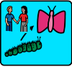

Growing and changing

Year 4,5,6

|  |  |  |  |
| --- | --- | --- | --- |
| **Key objectives** | **Year 4** | **Year 5** | **Year 6** |
| 1. I can explain the different types of relationships we can have. |  |  |  |
| 2. I can describe how relationships can change as we grow. |  |  |  |
| 3. I can identify why a relationship can be healthy or unhealthy. |  |  |  |
| 4. I know who I can speak to if I need help and if I feel uncomfortable with any of my relationships. |  |  |  |
| 5. I can explain the term personal boundary. |  |  |  |
| 6. I know there have been laws put in place to protect me. |  |  |  |
| 7. I know what the word puberty means. |  |  |  |
| 8. I know that boys and girls go through different changes in their body during puberty and I can describe some of them. |  |  |  |
| 9. I understand why my body goes through puberty. |  |  |  |
| 10. I know about different ways to cope with the changes in my body as it goes through puberty |  |  |  |
| 11. I can explain what the terms ‘conception’ and ‘reproduction’ mean |  |  |  |
| 12. I can describe the function of the female and male reproductive systems |  |  |  |
| 13. I can identify the various ways adults can have a child. |  |  |  |
| 14. I can explain the various different stages of pregnancy. |  |  |  |



Our working world

Year 4,5,6

|  |  |  |  |
| --- | --- | --- | --- |
| **Key objectives** | **Year 4** | **Year 5** | **Year 6** |
| 1. I can explain where the money comes from to pay for the services that help keep us safe and healthy |  |  |  |
| 2. I understand how I can contribute at home, at school, and in the  community. |  |  |  |
| 3. I can talk about different ways I can help the people who look after me. |  |  |  |
| 4. I know who pays for my education. |  |  |  |
| 5. I understand how to save money and why it is important to save. |  |  |  |
| 6. I understand the skills that I will need in my chosen future career. |  |  |  |
| 7. I can name some of the jobs that I can do to help out at home. |  |  |  |
| 8. I know and understand various money related terms. |  |  |  |
| 9. I can describe how to budget in order to buy things I may want or need. |  |  |  |
| 10. I can explain what the word “enterprise” means. |  |  |  |
| 11. I understand how we can spend money when using technology |  |  |  |
| 12. I can understand the consequences and impact of what could happen if I spend money online without permission. |  |  |  |
| 13. I know how to be respectful and responsible when using apps and games online |  |  |  |



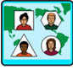

A world without judgement

Year 4,5,6

|  |  |  |  |
| --- | --- | --- | --- |
| **Key objectives** | **Year 4** | **Year 5** | **Year 6** |
| 1. I can describe the positive characteristics in others. |  |  |  |
| 2. I can explain why being different can be positive. |  |  |  |
| 3. I can name all of the things I am good at. |  |  |  |
| 4. I can set myself goals and try to improve in different areas of my life. |  |  |  |
| 5. I know there are different types of religions and beliefs in the UK. |  |  |  |
| 6. I can explain the importance of respecting peoples’ differences. |  |  |  |
| 7. I am enthusiastic to learn about how other people are different from me. |  |  |  |
| 8. I know how my opinions and judgements can affect others and that it is important to be positive |  |  |  |
| 9. I can recognise that everyone is entitled to live the life they choose, as long as they are not harming anyone |  |  |  |
| 10. I can explain why it is negative to live a life that creates harm for others |  |  |  |
| 11. I understand I should not allow the negative opinions that others may have, affect what I think and feel |  |  |  |
| 12. I can identify ways we can overcome barriers and promote diversity, equality, and inclusion. |  |  |  |
| 13. I can explain each of the British values |  |  |  |



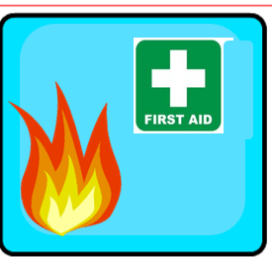

First aid

Year 4,5,6

|  |  |  |  |
| --- | --- | --- | --- |
| **Key objectives** | **Year 4** | **Year 5** | **Year 6** |
| 1. I can explain the meaning of first aid. |  |  |  |
| 2. I am able to recognise an emergency first aid situation. |  |  |  |
| 3. I can explain how to provide first aid treatment to someone who is struggling to breathe |  |  |  |
| 4. I understand and can explain the acronym ‘DRs ABC’. |  |  |  |
| 5. I know how to place someone in the recovery position. |  |  |  |
| 6. I can explain how to deal with a number of common injuries. |  |  |  |
| 7. I can recognise signs of a head injury. |  |  |  |
| 8. I am able to fill in an incident report form correctly |  |  |  |
| 9. I know how to how to make a clear and efficient call to the emergency services |  |  |  |

