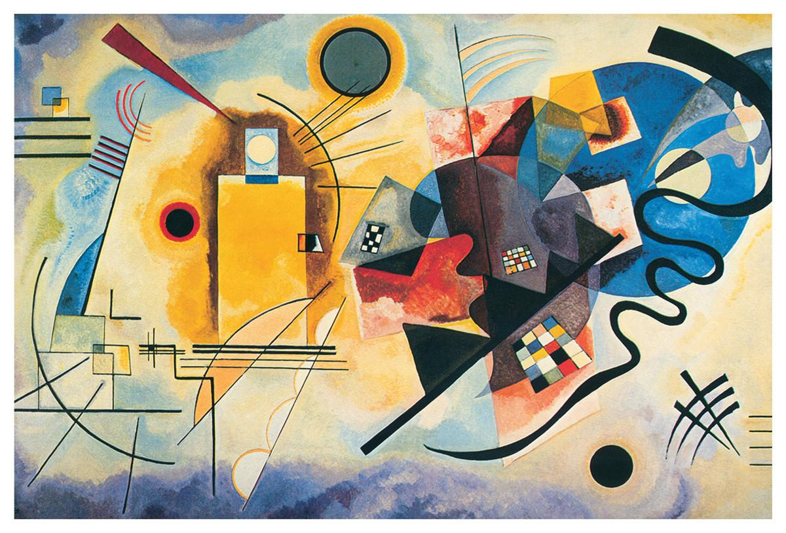

**Abstract Art. Wassily Kandinsky.**

Year 1. Art. Spring 2.

|  |  |  |  |
| --- | --- | --- | --- |
|  | **Key Objectives :** | **Start of unit** | **End of unit** |
|  | Can I can say what a tint is? |  |  |
|  | Can I say what a shade is? |  |  |
|  | Can I use black and white to make tints and shades? |  |  |
|  | Can I use colour to represent mood? |  |  |
|  | Can I say what I like about Kandinsky? |  |  |

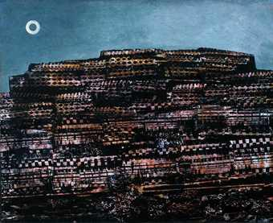

**Frottage. Max Ernst.**

Year 1. Art. Autumn 1.

|  |  |  |  |
| --- | --- | --- | --- |
|  | **Key Objectives:** | **Start of unit** | **End of unit** |
|  | Can I talk about and discuss what texture means? |  |  |
|  | Can I look at an artist piece using texture and explain how they have used different combinations of materials? |  |  |
|  | Can I say a fact about Max Ernst? |  |  |
|  | Can I put texture onto Clay and describe the texture? |  |  |
|  | Can I use frottage to transfer? |  |  |

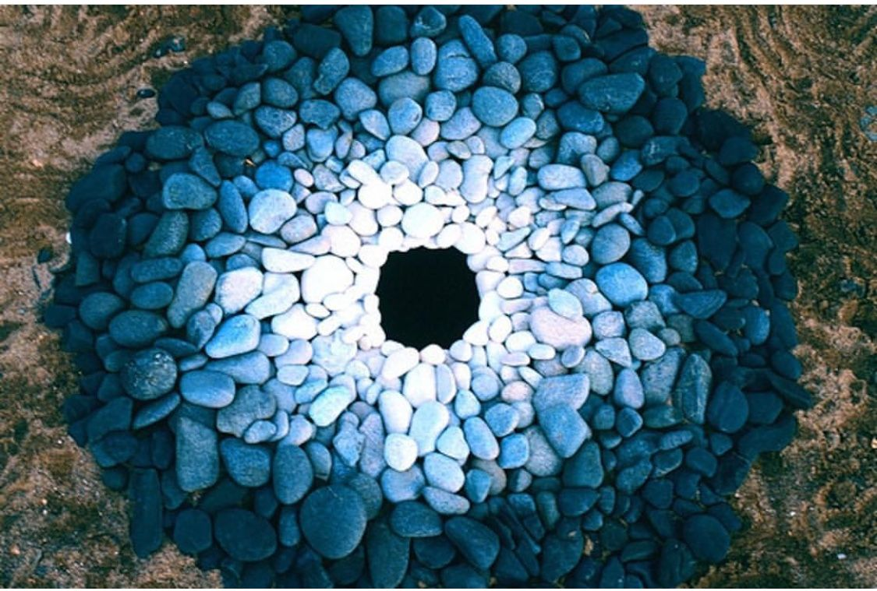

**Natural Art. Andy Goldsworthy.**

Year 1. Art. Summer 2.

|  |  |  |  |
| --- | --- | --- | --- |
|  | **Key Objectives:** | **Start of unit** | **End of unit** |
|  | Can I explain how to mix colours? |  |  |
|  | Can I explain how colour is used in Andy Goldsworthy work? |  |  |
|  | Can I identify shapes in Andy Goldsworthy work? |  |  |
|  | Can I use materials to make shapes? |  |  |
|  |  |  |  |