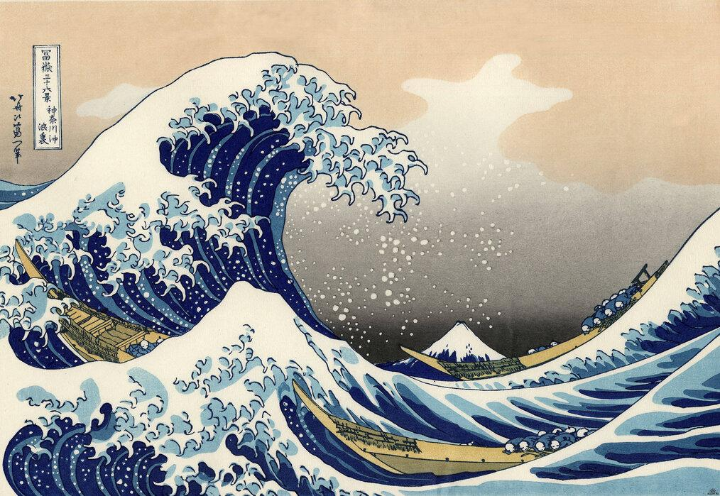



|  |  |  |  |
| --- | --- | --- | --- |
|  | **Key Objectives:** | **Start of unit** | **End of unit** |
|  | Can I understand what space means, focusing on positive and negative space? |  |  |
|  | Can I explain how an artist uses space? |  |  |
|  | Can I explain what form means? |  |  |
|  | Can I talk about how the artist uses form? |  |  |
|  |  |  |  |

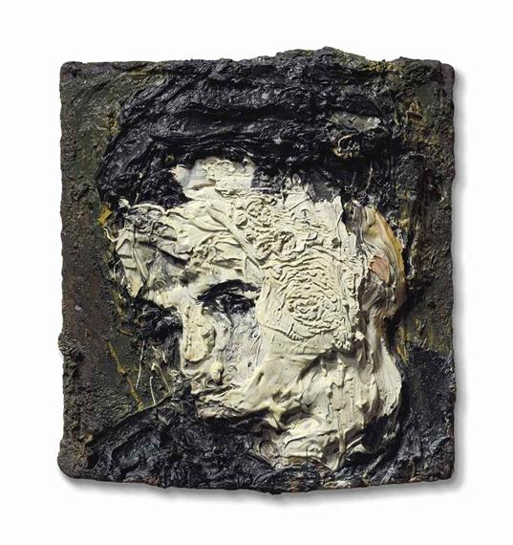

**Art expressionism** Frank Auerbach/Leon Kossoff

Year 2. Art. Spring 2.

|  |  |  |  |
| --- | --- | --- | --- |
|  | **Key objectives:** | **Start of unit** | **End of unit** |
|  | Can I explain what texture means? |  |  |
|  | Can I look at an artistic piece using texture and explain how they have used the different materials? |  |  |
|  | Can I use different Materials to create texture? |  |  |
|  |  |  |  |
|  |  |  |  |

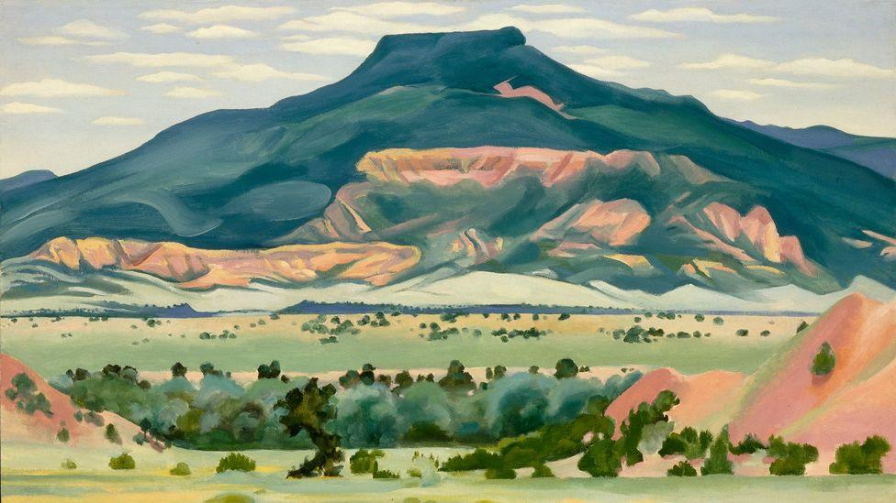

**Modernism/ O’Keeffe**

Year 2. Art. Summer 2.

|  |  |  |  |
| --- | --- | --- | --- |
|  | **Key Objectives:** | **Start of unit** | **End of unit** |
|  | Can I explain what shape means and identify shapes used in 2-D and 3-D pictures? |  |  |
|  | Can I describe what I can see, explain what I like about a piece, and describe how it makes me feel? |  |  |
|  | Can I explain what effect tone has and how different artists use tone? |  |  |
|  | Can I explain how different grades of pencils, pastels and chalk show different tones and the effect it has on the image? |  |  |
|  |  |  |  |