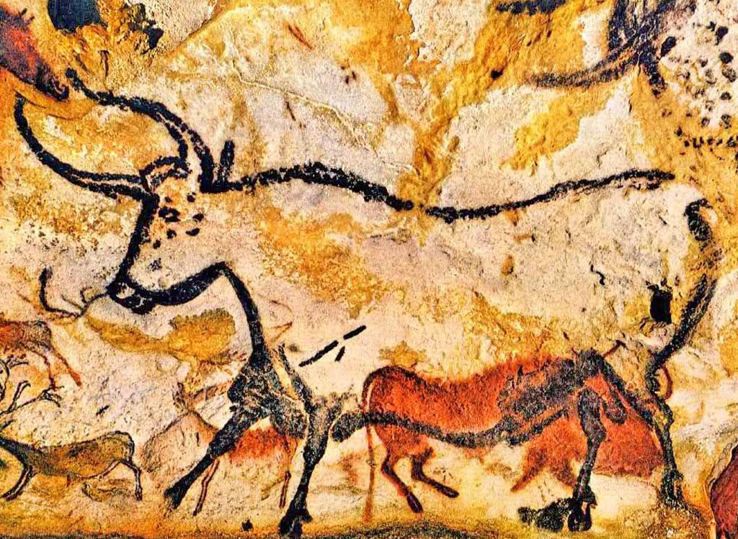

|  |  |  |  |
| --- | --- | --- | --- |
|  | **Key Objectives:** | **Start of unit** | **End of unit** |
|  | Can I identify different lines and talk about how line is used for effect? |  |  |
|  | Can I explore and discuss different thickness of line and how it can be used in different ways? |  |  |
|  | Can I Talk about how an artist uses line to represent things seen, remembered or imagined? |  |  |
|  | Can I use digital media to identify and research artists, craftspeople, architects and designers? |  |  |
|  |  |  |  |

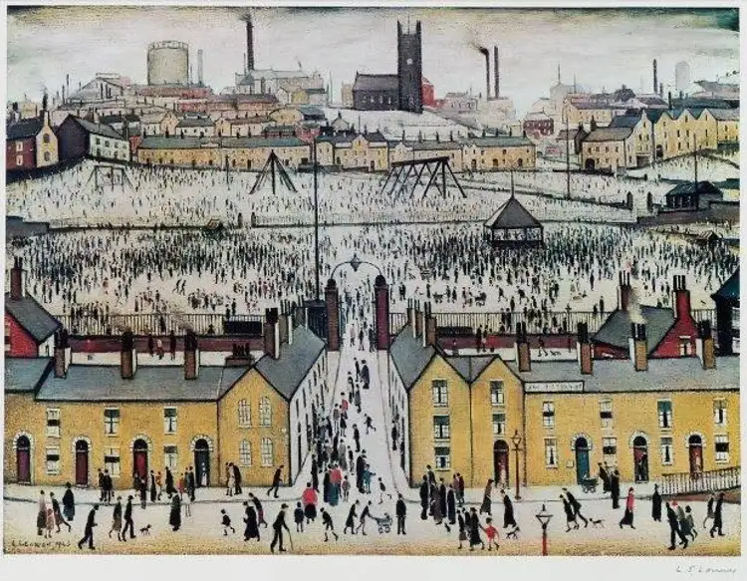

**Naïve Art. L. S. Lowry.**

Year 3. Art. Summer 2.

|  |  |  |  |
| --- | --- | --- | --- |
|  | **Key Objectives:** | **Start of unit** | **End of unit** |
|  | Can I identify different tones in a piece of work and talk about how tone is used? |  |  |
|  | Can I look at a focus artist; compare their work with other artists, discussing the effect of tones? |  |  |
|  | Can I use digital media to identify and research artists, craftspeople, architects and designers? |  |  |

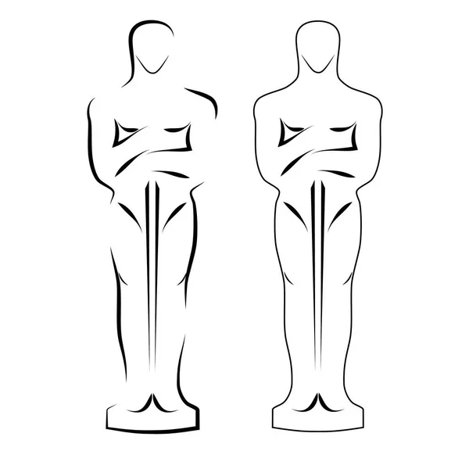

**Sculpture.**

Year 3. Art. Spring 1.

|  |  |  |  |
| --- | --- | --- | --- |
|  | **Key Objectives:** | **Start of unit** | **End of unit** |
|  | Can I identify different lines and talk about how line is used for effect? |  |  |
|  | Can I explore and discuss different thickness of line and how it can be used in different ways? |  |  |
|  | Can I talk about how an artist uses line to represent things seen, remembered or imagined? |  |  |
|  | Can I explain what Form means (3-Dimensional shape that can be held or walked around)? |  |  |
|  | Can I discuss how different artists use form? |  |  |