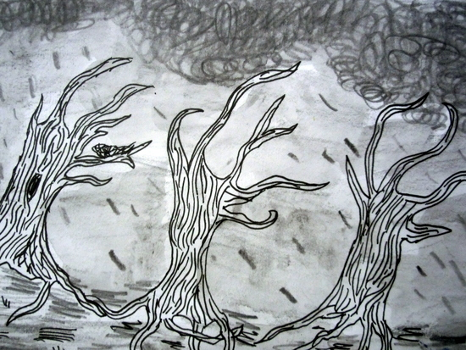

**Storytelling Through Drawing**

Year 4. Art. Autumn 2 .

|  |  |  |  |
| --- | --- | --- | --- |
|  | **Success Criteria:** | **Start of unit** | **End of unit** |
|  | To look at different art pieces and discuss and identify different tones in a piece of work. |  |  |
|  | Compare the work of Laura Carling and Shaun Tan with other artists, discussing the effect of tones. Why they are used? |  |  |
|  | Confidently identify different lines and talk about how line is used for effect and to represent things seen using charcoal. |  |  |
|  | Discuss artist intention and reflect upon your response with mood. |  |  |

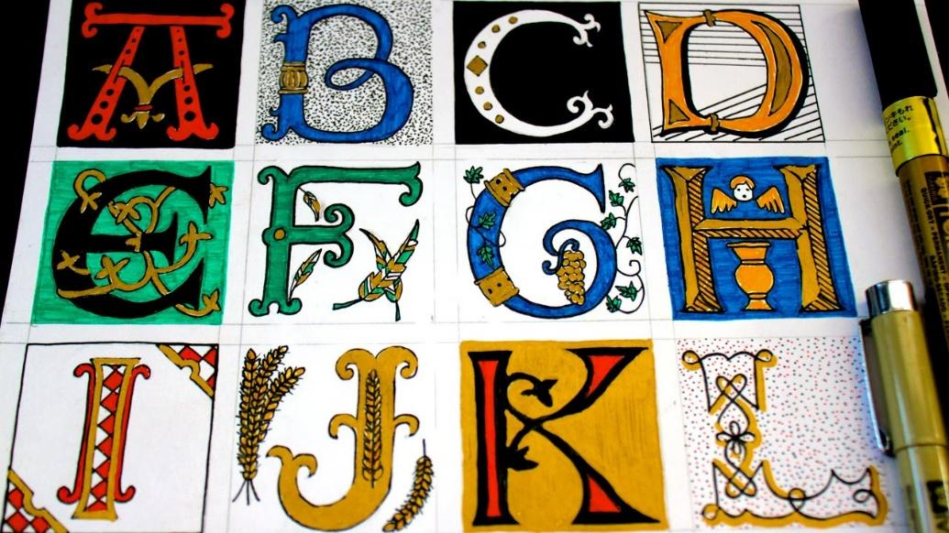

**Illuminated Letters.**

Year 4. Art. Spring 1.

|  |  |  |  |
| --- | --- | --- | --- |
|  | **Key Objectives:** | **Start of unit** | **End of unit** |
|  | Can I identify different shapes used in a piece of art. |  |  |
|  | Can I can understand what positive and negative space means in a piece of work. |  |  |
|  | Can I understand what space is in a picture and how its used. |  |  |
|  | Can I Talk/discuss how colour and tone create depth in pictures. |  |  |
|  |  |  |  |

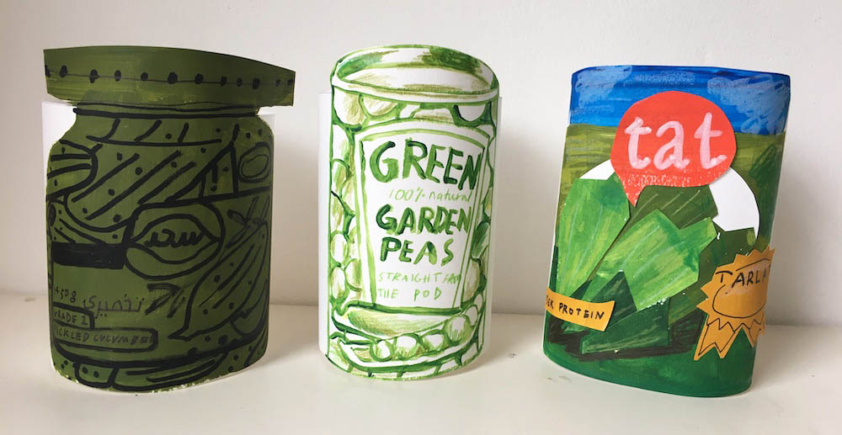

**Festival Feast**

Year 4. Art. Summer 1

|  |  |  |  |
| --- | --- | --- | --- |
|  | **Success Criteria:** | **Start of unit** | **End of unit** |
|  | Can identify how artists use textures to create mood through textiles. |  |  |
|  | Can identify how three-dimensional works of art and architecture use texture. |  |  |
|  | Identify and explore colour ideas through art techniques. |  |  |
|  | Compare how different artists use colour in their art pieces. |  |  |
|  | Explore and experiment using different colours to create moods. |  |  |