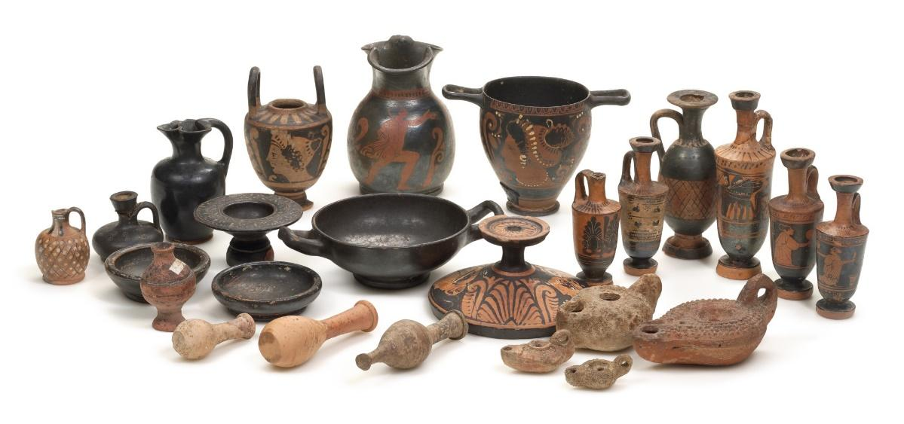

|  |  |  |  |
| --- | --- | --- | --- |
|  | **Key Objectives** | **Start of unit** | **End of unit** |
|  | Can I use shape in different art forms and use language to describe it? |  |  |
|  | Can I enable development of ideas, through a combination of design, making and drawn inspiration? |  |  |
|  | Can I explain what Form means (3-Dimensional shape that can be held or walked around)? |  |  |
|  | Can I explore architecture of another time and/or culture, and make individual work in response to what is seen? |  |  |

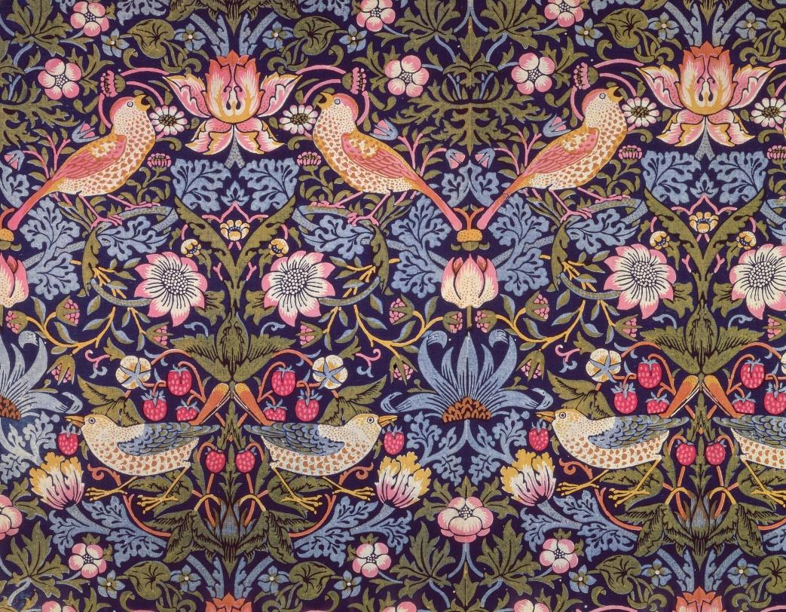

**William Morris.**

Year 5. Art. Summer 2.

|  |  |  |  |
| --- | --- | --- | --- |
|  | **Key Objectives:** | **Start of unit** | **End of unit** |
|  | Can I demonstrate how colour palettes build on a piece of work? |  |  |
|  | Can I show awareness and talk about how artists use colours to create different moods? |  |  |
|  | Can I confidently use shape in different art forms and use language to describe it, making links with focus artist? |  |  |
|  | Can I discuss problem and how they were solved. Think about what I might try next time? |  |  |

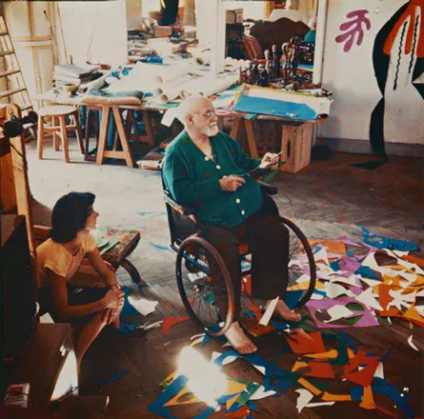

**Collage. Henri Matisse.**

Year 5. Art. Spring 1.

|  |  |  |  |
| --- | --- | --- | --- |
|  | **Key Objectives:** | **Start of unit** | **End of unit** |
|  | Can I research, discuss and identify how three-dimensional works of art and architecture use texture? |  |  |
|  | Can I use a range of different materials to show texture? |  |  |
|  | Can I compare how form is used in different pieces? |  |  |
|  | Can I Enable development of ideas, through of design, making and drawn inspiration? |  |  |