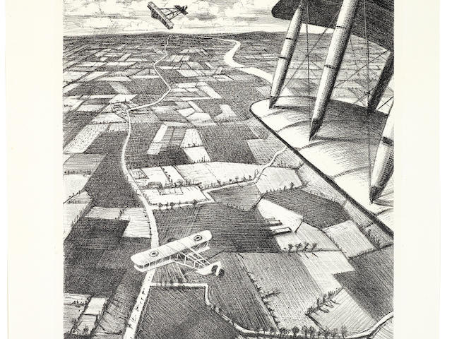

**World War Art. Christopher Nevinson**

Year 6. Art. Autumn 1 and 2.

|  |  |  |  |
| --- | --- | --- | --- |
|  | **Key Objectives:** | **Start of unit** | **End of unit** |
|  | Can I use their sketch book to record skills used by other artists, with independence? |  |  |
|  | Can I identify tones and discuss how they affect the piece of art, making links with the focus artist? |  |  |
|  | Can I talk about how different grades of pencils, pastels and chalk create tones in an art piece and how the artist uses them to create effect? |  |  |
|  | Can I confidently identify thickness of line and how it can be used in different ways. Use techniques to develop a piece of art? |  |  |
|  | Can I identify and show awareness of different hardness of pencils to show line, tone and texture. Talk about what effect it has to the image? |  |  |

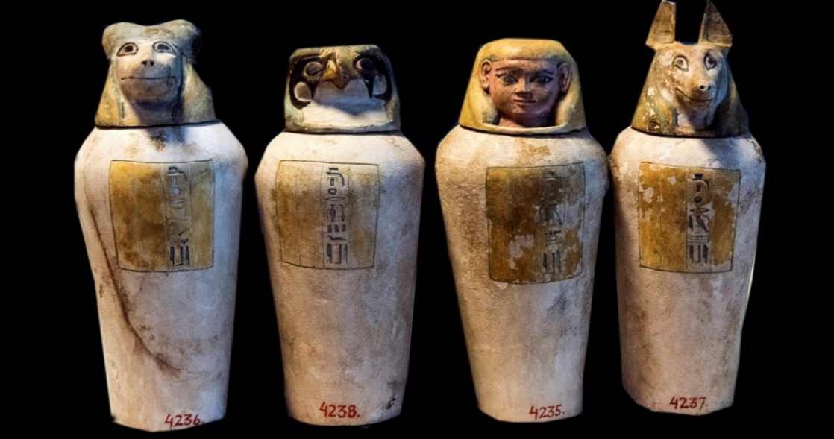

**Egyptian Art.**

Year 6. Art. Summer 1 and 2.

|  |  |  |  |
| --- | --- | --- | --- |
|  | **Key Objectives:** | **Start of unit** | **End of unit** |
|  | Can I confidently show awareness of space in a piece of work? |  |  |
|  | Can I confidently say why space has been used within an art piece and the effect it has? |  |  |
|  | Can I confidently knows what Form means (3- dimensional shape that can be held or walked around)? |  |  |
|  | Can I confidently demonstrates form in their work, showing how it visually effects pieces? |  |  |
|  | Can I say how form relates to the different aspects of art? | c |  |