

Millbrook Primary School – PE & Sport Premium Plan 2024–2027
1. Overview
Millbrook Primary School is committed to supporting all pupils to live healthy, active lives. The PE and Sport Premium grant has enabled the school to enhance provision, increase participation, and embed sustainable improvements in physical education and sport.
This report outlines how the funding has been allocated, the impact of key initiatives, and swimming outcomes for Year 6 pupils, in line with DfE guidance.
2. Statutory Duties and Strategic Priorities
The PE and Sport Premium must be used to:
- Support all pupils to live healthy, active lives, regardless of background or ability.
- Improve health, wellbeing, personal development, and academic attainment through physical activity.
- Provide high-quality PE and sport for at least 2 hours per week.
- Offer a wide range of extracurricular and competitive opportunities.
- Ensure sustainable improvements that benefit future cohorts.
Millbrook Primary School has focused its strategy on five key areas:
- Increasing staff confidence and skills in teaching PE.
- Boosting pupil engagement in regular physical activity.
- Raising the profile of PE and sport across the school.
- Broadening access to a wider range of sports and activities.
- Increasing participation in competitive sport.
3. PE & Sport Premium Spending Overview (allocated amount 2024-2025 £17,159; estimated allocated amount 2025-2026 £17598) – Spending for 2025-2026 to be reported in July 2026
3.1 CPD (Total: £7,706.50)
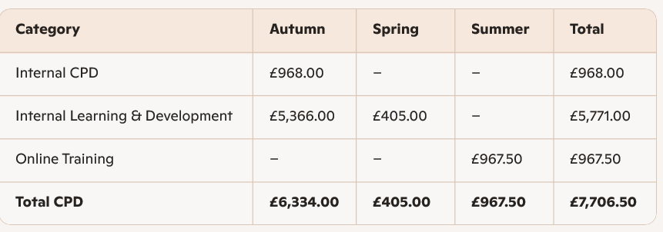
Commentary:
The school invested significantly in staff development to ensure high-quality PE teaching. This included internal training, learning and development programmes, and online training modules. These investments support long-term sustainability by improving staff expertise.
3.2 Internal Spend (Total: £13,744.52)
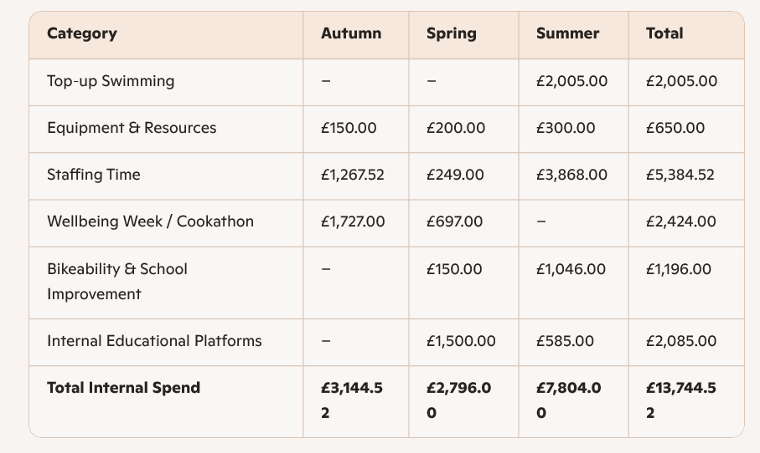
Commentary:
Internal spending focused on expanding opportunities for pupils, improving resources, and supporting targeted interventions such as top-up swimming. Staffing time ensured high-quality delivery of PE and extra-curricular activities.
3.3 External Spend (Total: £17,185.00)
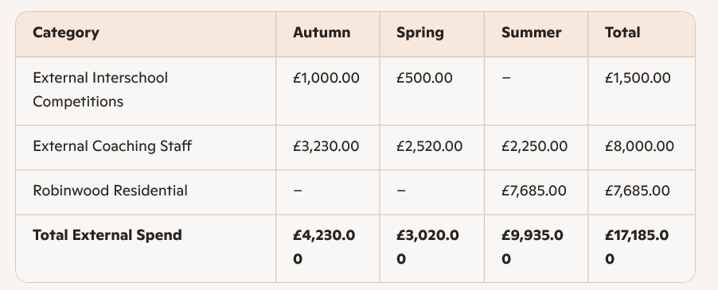
Commentary:
External spending enabled pupils to access specialist coaching, competitive opportunities, and outdoor adventure experiences. These activities broadened the curriculum and supported personal development.
4. Swimming and Water Safety Outcomes – Year 6
2025
Swim competently, confidently and proficiently over a distance of at least 25 metres | 68%
Use a range of strokes effectively (for example, front crawl, backstroke and breaststroke) | 68%
Perform safe self-rescue in different water-based situations | 68%
2026
Swim competently, confidently and proficiently over a distance of at least 25 metres | TBC
Use a range of strokes effectively (for example, front crawl, backstroke and breaststroke) | TBC
Perform safe self-rescue in different water-based situations | TBC

Commentary
Millbrook Primary School has used Sport Premium funding to support top-up swimming lessons for pupils not meeting national curriculum standards. This includes:
- Funding transport to swimming facilities.
- Providing additional instruction beyond core curriculum provision.
5. Impact of Funding
- Staff are more confident and skilled in delivering PE.
- Pupils are more engaged in physical activity and sport.
- The school offers a broader and more inclusive range of sports.
- Competitive opportunities have increased.
- Swimming attainment is improving through targeted support.
6. Accountability and Reporting
Millbrook Primary School will publish this report on its website by 31 July 2026, in line with DfE conditions of grant. The governing board has reviewed and approved the strategy and spending outlined in this report.
The school will also complete the digital expenditure reporting return, including swimming attainment data, to ensure transparency and compliance in July 2026.

