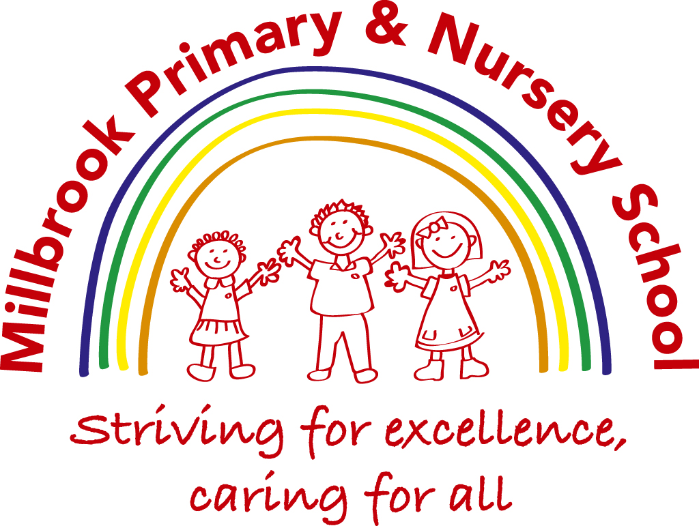

Teaching and Learning Policy

Contents:

- Statement of intent
- Roles and responsibilities
- Self-evaluation
- Learning environment
- Our philosophy
- Teaching strategies
- Assessment
- Early years foundation stage
- Key Stage 1 and 2
- Individual learning
- Monitoring and reporting
Appendices
1 Millbrook Teaching and Learning Standards
2 Learning environment checklist
3 Planning at Millbrook
4 Feedback at Millbrook
5 Writing Non negotiables
6 Presentation non-negotiables
7 Medium Term Planning
8 Foundation Planning proforma

Equality Statement

Our equality objectives are:

To promote spiritual, moral, social and cultural development through all appropriate curricular and extra-curricular opportunities. We aim to meet this objective with particular reference to issues of equality and diversity.

To reduce prejudice and increase understanding of equality through direct teaching across the curriculum.

To move beyond deterministic notions of fixed ability and to model teaching and learning behaviours that avoid labelling.

To narrow the gap in attainment in all subjects between different groups (boys and girls, pupil premium and non-pupil premium).

To promote cultural development and understanding through a rich range of experience, both in and beyond the school.

To eradicate prejudice related bullying in relation to the protected characteristics listed in the Equality Act 2010.

To tackle prejudice and promote understanding in relation to people with disabilities

Statement of intent
Every child has the right to the best possible education. We aim to ensure that all pupils, regardless of ability, special educational needs (SEN) or circumstances, reach their full potential and gain the skills and knowledge necessary to lead successful lives.
This policy provides procedures aimed towards ensuring high quality teaching and learning throughout the school.
It aims to:
- Embed an agreed range of good practice across the school.
- Ensure consistency throughout the school.
- Inform staff of the school’s expectations.
- Provide a unified focus for monitoring learning and classroom practice.
- Ensure that the needs of pupils are met.
- Improve and enhance the quality of teaching.
- Ensure that pupils are receiving a broad, balanced and relevant curriculum, meeting the requirements of the national curriculum.
- Ensure that teaching is appropriately differentiated for all pupils.
- Establish targets for improvement.
- Enhance the professional development of staff.

Signed by:
E.Turner | Headteacher | Date: | September 2025
M.Robinson | Chair of governors | Date: | September 2025

Roles and responsibilities

The role of governors

Governors will receive reports from the headteacher and curriculum coordinators and act upon areas identified as requiring improvement.

The curriculum sub-committee will meet regularly to monitor progress against targets.

Governors will visit the school to increase their knowledge of classroom activity. When visiting, governors will:
- Observe lessons.
- View recordings of lessons as appropriate.
- View samples of pupils’ work.
- View records of achievement.
- Talk to pupils about their experiences.
- Talk to teachers about their experiences and check on their well-being
- Report their findings to the entire governing body.

The role of the senior leadership team
The senior leadership team will:
- Take a general overview of the atmosphere in school on a day-to-day basis by visiting classes and talking to staff and pupils.
- Liaise with parents to ensure needs are being met.
- Work in classrooms, including teaching, regularly.
- Carry out focussed classroom-based observations.
- Judge the teaching not the teacher, using the following methods: lesson observations, data, work scrutiny, planning scrutiny, interviews with children, learning walks and environment scrutiny.
- Use lesson study and regular ongoing CPD into what makes great teaching to develop the teaching and learning across the school
- Discuss all annual reports with staff.
- Complete a self-evaluation.
- Report on the quality of teaching and learning in the governors’ report.
- Act as role models for teaching staff.

The role of the curriculum co-ordinators
Curriculum co-ordinators will:
- Develop and review curriculum policies and schemes of work in collaboration with colleagues.
- Take accountability for the progress of children in their given subject.
- Lead CPD meetings in their subject area to develop teaching and learning.
- Report on the effectiveness of the curriculum to the senior leadership team and the governing body.
- Provide professional advice to the governors’ curriculum sub-committee.

The role of teachers
Teachers will:
- Monitor and evaluate their teaching.
- Seek professional dialogue and constructive criticism from their head of department.
- Use lesson study, learning circles and regular ongoing CPD into what makes great teaching to develop and improve their practice.
- Review and evaluate their planning regularly.
- Set appropriate and challenging targets for pupils based on ability.
- Collaborate with colleagues to moderate pupil achievement.
- Involve parents and other professionals in the monitoring process.
- Complete an annual review assessing the progress of their pupils.

  - The role of pupils
Pupils are expected to:
- Be on time for school.
- Be prepared to learn.
- Place coats and bags in the appropriate area.
- Store personal belongings in the area provided.
- Not to eat or chew.
- Be attentive.
- Listen to and follow all reasonable instructions.
- Treat everyone with respect.
- Follow their classroom rules and learning promises

The role of the parent
Parents are expected to:

- Ensure that children attend school regularly and punctually and in good health
- Provide support for the discipline in school and for the teacher’s role
- Provide PE kit, keep up to date with school newsletters and notify school if their child is absent for any reason
- Give due importance to homework, for example reading with children and helping them to learn spellings and multiplication table facts
- Provide current contact details and details of any medical needs their child may have
- Discuss their child’s day

External monitoring
- External advisors will work on an annual cycle to support subject leads with their subject evaluation using pupil interviews and children’s books to identify areas for development.
- The support of leaders from local schools will be sought to evaluate the work of the school through professional discussion and joint lesson observations.
- Ofsted inspections will be used to identify strengths and weaknesses, and to develop an action plan for improvement.

Self-evaluation
  - Discussion with senior leaders

Senior leaders should discuss the following questions to assess the quality of teaching at the school:
- What is the school's view on teaching?
- What is being done to monitor teaching?
- How is assessment used to inform planning, ensure appropriate challenge, set targets and provide feedback?
- To what extent do teachers use assessment within the lesson (for example mini-whiteboards and questioning) to ensure that all pupils understand the lesson objectives?
- Are judgements based on the interpretation and evaluation of data and evidence?
- Are strengths and weaknesses in teaching and management identified?
- What strategies do teaching assistants employ to support learning?
- Do pupils work independently, co-operate to solve problems, develop workplace skills and understand what they need to do to improve?
- What happens if pupils are absent or fall behind with their work? What support is in place to help them?

  - Discussion with pupils

The following questions should be discussed with pupils to assess the quality of teaching at the school:
- Do you know how well you are doing? Do you know what you need to do to improve?
- What subjects do you receive feedback in?
- How often do you work on improving your work?
- How do you know when you have successfully improved your work?
- Who helps you to improve your work? What sort of things do they do?
- Do your parents know your what you need to do to improve? How do they know?
- Tell me about this piece of work. What were you learning?
- Show me a piece of work that you are really proud of. Why?
- Do you know how to improve your work? Do you have the opportunity to improve your work?

Learning environment
  - Setting the tone
The teacher will set the tone for the morning and afternoon sessions by taking the register. If no formal register is taken, the teacher will call out the names of the pupils to catch their attention and to indicate that the session has begun.

  - Seating arrangements
The teacher will consciously decide upon and plan the seating arrangements for pupils in order to maximise educational attainment. Arrangements will be changed to suit different activities and to allow students to work independently.
  - The classroom
It is imperative that the learning environment maximises opportunities to learn. Displays are changed regularly and geared towards aiding learning, not providing distraction. Desks should be free from clutter and arranged in a manner providing suitable space for all. The room is well-ventilated and maintained at a suitable temperature. All pupils are encouraged to drink water during lessons. Regular environment checks will be carried out using the learning environment checklist (appendix 2).

Our philosophy
At Millbrook Primary and Nursery School we follow The Millbrook Teaching and Learning Standards of Engage, Challenge and Process (see Appendix 1)
Through our teaching philosophy, pupils are encouraged to:
- Listen to each other.
- Adopt various roles in groups.
- Volunteer thoughts and opinions.
- Respect the thoughts, ideas and contributions of others.
- Give honest and positive feedback.
To encourage all pupils to contribute to lessons, teachers:
- Adopt a no ‘hands-up’ rule, where all pupils are expected to contribute.
- Allow sufficient thinking time between questions to allow pupils to consider their responses.
- Plan time in their lessons for pupils to discuss their learning with a partner or group before committing to a response.
We reward and recognise achievement in the following ways:
- Teachers praise more than criticise, using formal and informal approaches
- The school formally rewards pupil in the following ways:
  - Dojos which could as credits towards the school house system
  - Calling the pupil’s parents praising the pupil
  - Sending a letter/dojo message home praising the pupil
  - Inviting the pupil to see the headteacher
  - Achievement assemblies
  - Privilege cards
  - Weekly Golden Time
- The school informally rewards pupils in the following ways:
  - Congratulating pupils privately or in class
  - Saying ‘well done’ to the whole class
  - Giving positive verbal feedback
The teacher will manage disruptive behaviour by:
- Following our behaviour policy and Good to Be Green/Rainbow Reflections system
- Using non-verbal cues such as raising eyebrows or frowning.
- Referring to the pupil by name.
- Quietly speaking to the pupil while the rest of the class is engaged.
- Giving the pupil a task to encourage responsibility.
- Reminding the pupil of the sanctions that follow a poor choice.
- In exceptional circumstances, calling for support from another member of staff –
To ensure that the quality of teaching is of the highest standard, we commit to ensuring that our teachers:
- Understand what excellent teaching is.
- Creatively plan and deliver lessons.
- Motivate pupils effectively.
- Enjoy and have a passion for teaching.
- Continue to learn and enhance their skills through lesson study and regular ongoing CPD.
- Hold high expectations for all pupils.
- Understand how thinking and questioning develop learning.
- Are consummate professionals.
- Engage pupils of all abilities.
- Seek out and accept constructive feedback from peers, pupils and parents.
- Are given opportunities to lead.
- Involve parents and carers in their teaching and pupils’ learning
- Understand and implement effective behaviour management strategies.
What is learning?

At Millbrook we believe:

- Learning is highly individual.
- Learning usually involves a progressive change in what a student knows and can do
- Learning involves extracting information from, and making sense of, experiences
- Learning frequently comes from student self-elected or self-generated experiences
- Learning is multi layered

What does this mean for teaching?

At Millbrook we believe teachers should:

- Design learning activities with students memories in mind
- Engage students in activities that enable them to revisit concepts
- Monitor individual students evolving understanding of concepts
- Focus on the "big question" (smaller number of big questions or problems in greater depth)
- Capitalise on peer culture to foster learning
- Over time, encourage students to manage their own learning activities
- In short we expect teachers to engage, challenge and offer opportunities to process in each lesson.

At Millbrook Primary we believe great teaching comes from teachers identifying their own performance development targets from the Great Teaching Toolkit:
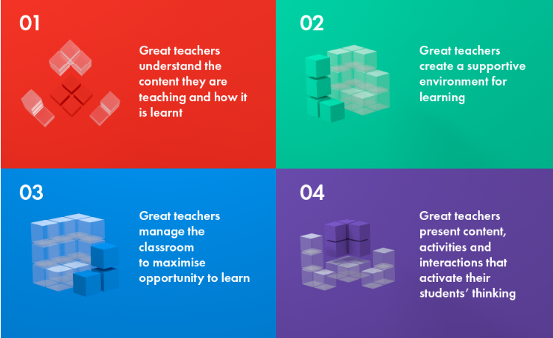We believe the following are characteristics of excellent teachers:
1. A passionate commitment to doing the very best for their students
2. A love of children enacted in warm, caring relationships
3. Excellent pedagogical content knowledge - the ability to identify, present and explain key concepts
4. An ability to use a variety of models of teaching and learning
5. Collaborative working style with other teachers to plan, observe and discuss one another's work
6. Constant questioning of, reflecting on and modifying their own practice

Teaching strategies
  - The curriculum
Reception classes follow the Early Years Foundation Stage (EYFS) profile. Years 1-6 follow the national curriculum.
The curriculum is balanced, with suitable proportions of time spent on statutory and non-statutory subjects. The curriculum is carefully timetabled and content is suitable for the age and ability of the pupils. In addition, the curriculum is made accessible to all through differentiation and the provision of the necessary resources.
While teaching the national curriculum, wider aspects of learning, such as personal development and relationship education, also form a significant part of pupils’ education.
  - Planning and preparation
Lessons are clearly linked to the national curriculum. They are differentiated to clearly show how pupils of all abilities are catered for. Lessons have clearly identified learning objectives and success criteria, showing continuity from one lesson to the next. In addition, lesson plans clearly show how teaching assistants are used to enhance learning. Plans may also contain a list of resources to be used during the lesson and how these resources will complement teaching (see medium term planning template Appendices 3 and 4). The school gives teachers adequate preparation, planning and assessment (PPA) time.
Planning will be adapted through assessment of learning strategies to ensure that it meets the learning needs of the cohort.
Feedback
Feedback and marking have two purposes. One, students act on feedback and make progress over time. Two, it informs future planning and teaching. See Feedback Policy
- Teachers must have a secure overview of the starting points, progress and context of all students.
- Feedback must be primarily formative including fix its which are clear about what students must act upon and selective marking, where relevant.
- Feedback must be regular
- The feedback code must be used.

Planning
Planning is a process not a product. It has one purpose, to enable first quality teaching which meets the needs of all students.
- Be clear and precise about the knowledge/skills you want students to learn, not what you want them to do.
- There must be evidence of long-term planning, in schemes of work, and short-term planning in the planning files.
- Adapted teaching should be planned over time to ensure a ‘quality first’ approach which meets the needs of all students and groups and maximises the use of any additional adult(s) in the room.
- All lessons must get off to a flying start, with students purposeful from the beginning.
- Consider timings to ensure appropriate pace for the intended learning.
Teach
- Go with the learning: the ‘flow’ of great progress is more important than following a lesson plan.
- Ensure that learning has stuck, through checking that is incisive and systematic.
- We are all teachers of literacy. The quality of both students’ and teacher’s language, such as in instructions and questioning, are significant determinants of progress. Make the implicit, explicit.
- All students must be working harder than the teacher, over time.
- Teachers must be explicit about learning outcomes and key words.
- Demonstrate the values of the school.
  - Reinforce students’ aspiration for success by the challenge you offer.
  - Enable them to show resilience by taking a risk and working through barriers.
  - Each class is a learning community in its own right. Their success depends on each other.
  - Delivery
Lessons are delivered in a confident, lively style with good projection. Lessons are balanced, in terms of teacher and pupil-led activities, and cater for different learning styles. A range of lesson types are used including practical, visual, dramatic, investigative and group work. Lessons are flexible and mainly taught in mixed ability groupings unless it is guided reading/writing, phonics or guided maths.
  - Resources
Resources are prepared in advance and made readily available to pupils. They are accessible to all and appropriate for the learning objectives of the lesson. In addition, they cater to pupils’ different learning styles. Resources are shared between teachers in order to facilitate good practice.
  - In-class support
Teaching assistants are actively involved in the lesson to aid pupils’ learning. They are involved in prior planning and preparation, and possess a good knowledge of the needs of individual pupils. They support different groups at different times this includes teaching mixed ability groups in the integrated model. In some circumstances, teaching assistants are utilised on a one-to-one basis with a child in need of additional help.
  - Pupil involvement
Pupils are provided opportunities to follow-up teachers’ feedback. Pupils are also allowed opportunities to mark their work (self-assessment), and that of their peers (peer assessment), following the school’s feedback guidelines (Appendix 4). The learning objective of each lesson is explained at the start and displayed throughout.
  - High expectations
The school sets high expectations for all pupils, regardless of ability, circumstances or needs.
  - Special educational needs and disabilities (SEND)
Pupils with SEND are treated as individuals. Every pupil is provided with the appropriate support. Children causing concern are discussed with the SENCo and, if necessary, additional professional support is provided. Teachers also discuss, informally, the needs of individual children, enabling all teachers to be aware of pupils requiring support. In addition, the school has adopted a policy containing policies and procedures for assisting our pupils with SEND. We use EEF best practice 5 a day approach.

Assessment

Baseline assessment

Pupils joining the school in Years 1 -6 will receive a baseline assessment when they start.

Strategies for baseline assessment include:
- Assessing pupil progress over the first six weeks that they are enrolled.
- Past papers

Reception pupils will complete a statutory baseline assessment in the first 6 weeks of the autumn term.

Formative assessment (assessment for learning)

Formative assessment creates a positive learning environment where children can see the steps necessary for their own success. It enables teachers to set appropriate work at the level necessary for the children’s continuing progress.

Formative assessment is a powerful way of raising pupils’ achievement. It is based on the principle that pupils will improve most if they understand the aim of their learning, where they are in relation to this aim and how they can achieve the aim.

Formative assessments are used to:
- Identify children’s strengths and gaps in their skills/knowledge.
- Identify the next steps for learning.
- Inform future planning.
- Enable appropriate strategies to be employed.
- Facilitate the setting of appropriate targets for the class, group and individual.
- Track the child’s rate of progress.
- Facilitate an evaluation of the effectiveness of teaching and learning.
- Inform future teaching and learning strategies.
- Identify individuals and groups for specific intervention support.

Formative assessment will not be punitive. It is used to guide teaching and learning and help pupils achieve their targets. It is not used to judge a teacher’s performance.

Formative assessment is not included as part of a pupil’s final grade, but will be taken into account as part as their summative assessments.

Methods of formative assessment include the following:
- Question and answer sessions
- Hot seating
- Quizzes – retrieval exercises
- Self-assessment

Summative assessment (assessment of learning)

Summative assessment is important for:
- Accurate information regarding a child’s attainment and progress.
- Informing both parents and teachers of a child’s attainment and progress.

Summative assessments:
- Identify attainment through one-off tests at any given point in time.
- Record performance in a specific area on a specific date.
- Provide end of key stage test data against which the school will be judged.
- Ensure statutory assessments at the end of KS1 and KS2.
- Provide information about cohort areas of strength and weakness to build from in the future.
- Are part of the evidence used to determine a pupil’s final grade.
- Are used to monitor the progress of individuals and groups of pupils.

Methods of summative assessment include:
- Termly tests
- External examinations such as the national curriculum tests.
- Assessment through talk – using the Chris Quigley Assessing through Talk in Reading, Writing and Maths

All assessment procedures for 2024 / 2025 can be seen in our assessment procedures policy.
- Early Years Foundation Stage
See EYFS assessment procedures

1.1 Evidence and Assessment
In the Early Years Foundation Stage (EYFS), assessment is an integral and continuous part of the teaching and learning process. Our setting uses Evidence Me as a key assessment tool to support holistic observations and inform both formative and summative assessments. Practitioners regularly capture a wide range of observations across all areas of learning and development, ensuring that each child’s interests, progress, and next steps are accurately documented. Evidence Me enables staff to reflect on each child’s journey, celebrate achievements, and tailor learning experiences accordingly. This approach ensures a well-rounded understanding of every child’s needs and development, promoting high-quality, responsive teaching and supporting effective communication with parents and carers.

  - Focus activity

During focused activities, teaching staff develop children’s early language and vocabulary by using a range of strategies. Staff identify the level of support needed or if the work was completed independently. Children are encouraged to discuss their work using talk partners, and next steps are discussed with the children in friendly terms. Challenges are incorporated into the continuous provision so that children can apply what they have learnt in the focused activity session. Staff model and scaffold children’s learning so they can apply their skills and knowledge independently through play.

Information collated over the year from Reception baseline, Evidence me assessments, observations of the children, and teacher knowledge provides the evidence base for the Early Learning Goals at the end of Reception.

- Key stage 1 and 2
Teachers use assessment for learning to provide on-going assessment, through the use of focussed feedback (see feedback policy) and/or observations of children’s work, against learning objectives and success criteria. This information is then used to assess progress towards meeting learning targets, and to identify and set next step targets for each child.

Annotated plans and planning notes, made by class teachers and other adults involved with each child, record other important information about the progress of children in the class.

Twice yearly tests may be used to identify progress and gaps in learning. The tracking grids identify under-achieving pupils and set targets in reading, writing and maths for individual pupils and groups.

Termly pupil progress reviews are used to identify and analyse progress and set targets in reading, writing and maths for classes and cohorts.

Pupils receive regular and timely verbal feedback on their progress.

Planning for assessment

The national curriculum programmes of study are used to guide our teaching. These documents provide us with the framework to ensure breadth and balance in our curriculum.

Lessons contain clear learning objectives, based upon the teacher’s detailed knowledge of each child. We strive to ensure all tasks set are appropriate to each child’s level of ability.

Teachers use formative assessment and feedback (appendix 4) to assess children’s progress in relation to the planned learning objectives, and set the next steps to show where the child is in relation to this aim and how they can achieve the aim. Teachers use this information when planning for subsequent lessons.

Assessment methods/materials

Teachers use a range of assessment tools and materials (including analysis of children’s work in books, guided reading records and results of class tests/published tests), alongside on-going focussed feedback and notes of pupil observations, to inform their assessment of progress for individual pupils and groups. (See Assessment Procedures)

Results of published tests are used to contribute to overall teacher assessments.

Reporting

Reporting to parents/carers provides the opportunity for communication about their child’s achievements, abilities and future targets. End of year reports are written so that they have a positive effect on pupils’ attitudes, motivation and self-esteem.

We provide opportunities for three parent consultation evenings so that parents can discuss how well their child has settled and are able to be involved in the target setting process. In addition, we provide opportunities for a mid-year progress report and a final end-of-year report.

We provide an end-of-year written report which includes the results of statutory tests and assessments, and gives information relating to progress and attainment

We give parents the opportunity to discuss their child’s progress, by appointment.

Moderation

Regular moderation takes place each term to ensure consistency. Teachers meet in phase groups, cross phase groups and cluster school networks to analyse children's work against national curriculum or EYFS requirements. During the summer term, teachers in Year 6 are involved in formal teacher assessments, as part of end of key stage assessments and LA moderation.

Individual learning
  - SEN Profiles

SEN profiles are available for pupils who are not progressing as expected and are on the SEN register to allow pupils to lead their own achievement.

SEN profiles are reviewed termly to ensure that they are still effective.

  - EHC plans

Some young people with SEND may require additional support from professionals outside of the school setting. In these cases, the views of parents, psychologists and further specialists will be sought. Based on these views, and in collaboration with the pupil, an education, health and care (EHC) plan will be sought.

EHC plans replace statements of special educational needs. They include special educational provision, health provision and social care provision. More information can be found in the school’s special educational needs and disabilities policies.

Monitoring and reporting
This policy will be reviewed annually by the curriculum and achievement sub-committee.
The governor’s annual report will contain updates and analysis regarding teaching and learning at the school.

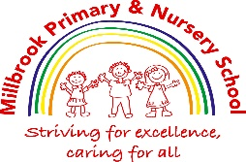

Appendix 1
Engage | Clarity –  Does everyone know what they are learning? Are concepts referred to?  Enquiry –  What question is being explored?  Revisit –  How does it link to prior learning? Is retrieval practice appropriate?  Purpose –  Why is it being learnt?  Model –  Are there opportunities to demonstrate what a good one looks like?
Challenge | Questioning –  Are you teaching to the top?  Are you using challenging and linked vocabulary?  Pace/Assessment –  Are you setting time related targets?  Are you moving the children on in their learning at the right pace?  More modelling? Guided Group Work? Independent?  When scaffolding are you planning for the least help first with a gradual withdrawal to independence?
Process | AFL –  What have they learnt?  Can they articulate their learning?  Are they able to independently apply it when it is revisited?  Have you planned and prepared opportunities for them to practice?  Do they understand what to do with feedback? Success criteria? Across the curriculum?  Are Knowledge Organisers used to support Friday Reflections review of learning?
Oracy – Are you building in opportunities for discussion and debate throughout?
No hands up – partners, cold call, group debate and feedback, whiteboards, Say it again better, sentence stems.
Effective Use of TA
Effective use of Teacher
Effective Use of Resources including IT
Independent application or scaffolded
Books need to clearly represent the child’s learning journey, show progress as a result of timely feedback and show high standards of presentation and care.
Children should be able to clearly articulate their learning in all areas of the curriculum.
Working Walls should be consistent and support children with their learning.
Appendix 2


Millbrook Primary School Classroom Environment Checklist Year 1-6
Area | Completed
General
All classrooms are tidy- tables, display areas are clutter free
The correct equipment and materials are available at the start of the lesson
Timetables are displayed
Millbrook Values are displayed
Teaching and learning contract on display
Love of reading displayed- (focus author displayed)
Child friendly SDP displayed
Reward system displayed (consistent with rest of school)
Display to support learning
A visual timetable is displayed in every classroom
A wall of achievement shows good examples of learning and values individual achievements
Curriculum displays include statements and questions to highlight key learning points and concepts are clearly displayed
Displays reflect current topics, include children’s work & are interactive to further support learning
English and Maths working walls reflect current teaching and learning and contain key vocabulary and worked good example. Examples of handwriting are displayed
RWI complex speed sounds posters displayed
AFL is evident through posters / traffic lights / Teaching and Learning promises
Marking feedback codes are displayed
Sentence stems are displayed to support Friday reflections
A Cultural display/British values/diversity.
Map of the world/map of UK/History timeline (KS2) displayed
Engage, Challenge, Process displayed
Vocab/questioning
Probing and processing questions are displayed
Key words/technical vocabulary is displayed for a variety of curriculum areas. Word of the day/words to be clarified displayed- use of word jar
Behaviour
Good to be green system is displayed
Class rules are displayed and framed positively
Learning behaviour posters displayed (Ks2 Give me 5 poster)
Emotional register & zones of regulation displayed
School bullying information displayed
Use of class dojo to display dojo rewards
Positive rewards are given for good behaviour e.g. dojos, table points, stickers
Classroom Practice
Feedback is given and acted upon across the curriculum
Topical books are displayed, book box is tidy and regularly changed
In EYFS and KS1, role play areas are relevant to children’s interests
Safeguarding
E-safety Posters displayed
Safeguarding Poster

Appendix 3
Maths
Long Term Planning
- Use units from the 2014 National Curriculum and Power Maths scheme of work which includes:
- Number
- Place Value
- Fractions
- Measures
- Data
- Algebra
- Geometry (Shape)
Medium Term Planning
- Follow the programme of study from the 2014 National Curriculum for your year group.
Short Term Planning
Weekly planning must show evidence of:
- Clear learning objectives (e.g. I can... or Can I... statements)
- Success criteria / AFL (Assessment for Learning)
- Targets
- Guided group/reasoning sessions
- Scaffolding (strengthen and deepen)
- Facilitation
- Support
- Independent / paired / group work
- Assessments (including annotations)
English
Long Term Planning
- Units of work should follow the Talk for Writing process: Imitation, Innovation and Independent Application.
- Make cross-curricular links
- Teach poetry through guided reading and cross-curricular lessons
- Cover year group objectives and ensure pupils learn the year’s word list (differentiated as needed)
Medium Term Planning
- Follow the programme of study from the 2014 National Curriculum for your year group.
Short Term Planning
Weekly planning must show evidence of:
- Clear learning objectives (I can... statements)
- Targets
- Scaffolding (strengthen and deepen)
- Facilitation
- Support
- Independent / paired / group work
- Assessments (including annotations)
- AFL
- Success Criteria
Science
Long Term Planning
- Science should have its own long-term plan in line with SNAP Science
Medium Term Planning
- Use the programme of study from the new National Curriculum for your year group.
Short Term Planning
- Use the Snap Science scheme, adapted to suit the needs of the children
- Include scaffolding in each lesson plan
Foundation Subjects
Long Term Planning
Each subject has its own long-term plan and supporting scheme of work:
- History – Collins
- Geography – Connecting Geography (Collins)
- D&T – Projects on a Page
- RE – Agreed Syllabus for Tameside
- French – Primary Language Network
- Music – Charanga
- Computing – TEACH Computing
- Art – Access Art
- Science – Snap Science
- Maths – Power Maths
Medium Term Planning
- See Appendix 6 for expected proforma
Short Term Planning
- Adapt medium-term plans to meet the needs of the children
- Include scaffolding in each lesson
- See Appendix 7 for proforma

Appendix 4
KS1 Feedback Code
A key to explain the symbols used by your teachers when they mark your work.
→sp  I woz running. | Spelling
t he cat jumped.  →CAP | Capital letter
→P  The dog barked  →. | Full stop or punctuation missing
? | Does this make sense?
→fs | Finger spaces
→hw | Handwriting
→great x3 | Practise spelling 3 times
→ j j | Practise your handwriting

KS2 Feedback Code
A key to explain the symbols used by your teachers when they mark your work.
→sp | Spelling  (Underlined word)
t he cat jumped. | Missing capital letter or punctuation
→CAP | Capital letter
→P | Punctuation
? | Does this make sense?
→fs | Finger spaces
→hw | Handwriting
→great x3 | Practise spelling 3 times
/ | Begin a new sentence
// | Begin a new paragraph
# | Start a new line
* | Add more detail

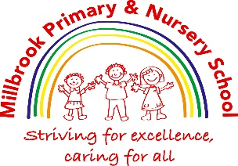
Appendix 5
Writing Non-Negotiables
- Units of work should follow the Talk for Writing process: Imitation, Innovation and Independent Application.
- Grammar tasks should be linked to purpose/book.
- Books should have neat presentation and sheets stuck in.
- Children can be encouraged to write their own pupil voice or self-assessment on pictures/PicCollages of drama activities. E.g., what would you change if you did that again?
- KS1: Use the same template for I can
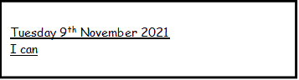

- Child friendly feedback code sheet to be stuck at the front of each English book.
- Children must prove to Miss Turner they have neat handwriting and get a pen license from her.
- Most pieces of writing should have fix its. (Year 2 upwards)
DAB it:
Used to improve the whole paragraph. Lined/handwriting paper used to re-write the paragraph with enhancements. This should be glued to the margin and left loose so that both pieces of work can be seen.
From this:
Monday 1st January 2021
I can write a story.

Once upon time, widow and jack lived on a farm.

Jack helped his mum with chores. But they were poor and had no food.
To this:
Monday 1st January 2021
I can write a story.

Once upon time, widow and jack lived on a farm.
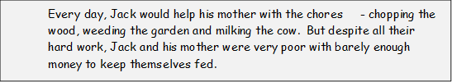

Jack helped his mum with chores. But they were poor and had no food.

Quantity of piece of work a week in English books:
- 2-3 in year 1
- 3-4 in year 2
- 4-5 in KS2


Golden Books
Golden books are a celebration of writing.
In KS2, children should produce a double page spread in their golden books once every half term. (2/3 a year)
In KS1, ‘hot writes’ can be photocopied or copied neatly onto handwriting paper to be stuck in. However, double page spreads can be done also. Work in golden books once every half term. (2 a year)

How to plan for golden books:
- Each half term, your writing should have a purpose/audience. Link the golden books with this. For example, if you are planning to write a letter to the care home, this can be produced in the golden books, then photocopied for the care home.

- The double-page spreads allow the children to become involved in considering the design of a text, alongside the usual text-type features. When looking at the toolkit of a non-chronological report, the children can begin to think about how they will set out their own. When writing narratives, the children can look at illustrations from the book to inspire them.

- Teachers can use their judgement as to whether the children write the ‘hot write’ straight into the golden book or draft it in their English books first. It’s recommended they draft it in their English books first to have the opportunity to discuss fix it’s, additions and improvements.

- It’s a good idea to allow the children to use a piece of paper to sketch out how they would like their writing to look in the golden books.

- Golden Books an important step for the children to become actual authors and understand how they can make their writing appeal more to the reader – your audience!

Golden Books will be displayed in the corridor for you to display a book each half. This will show progression from year 1-6 and be a good opportunity to share ideas.

Appendix 6
Presentation Non - Negotiables
KS1
- Dates and I can’s will be provided for the children where appropriate in the selected format
- Worksheets will only be used when absolutely necessary. When they are used they will be stuck in carefully.
- In Y2 each new piece of work will begin on a new page.
- Each new piece of work will have the date and I can.
- Good practice in handwriting will be encouraged at all times.
- Writing must be on handwriting lines and finger spaces must be used.
- In Maths, the children will need to write one digit one square. Spaces between sums will be encouraged. Rulers will be used.
- Mistakes will be rubbed out carefully or fixed with a fix it pen.
- Traffic lights, fix its and self and peer assessments must all be neatly produced.
- Teacher’s handwriting will model best practice.
KS2
- The children will write the date and title. They will be underlined with a single ruler line. There will be a space between the date and title.
- All written work will start against the margin.
- Worksheets will only be used when absolutely necessary. When they are used they will be stuck in carefully.
- Each new piece of work will begin on a new page. Each new piece of work will have the date and title.
- Good practice in handwriting will be expected at all times.
- Children will be expected to use joined handwriting from Y3 onwards, pens will be used once joined handwriting is mastered.
- Writing must sit on the line and finger spaces must be used.
- If the children make a mistake a single ruler line will be used to cross it out.
- Fix its to be completed in purple pen
- ‘Dab it’ paper slips will be used for editing and improving written work in English.
- In Maths, the children will need to write one digit per square. Spaces between calculations will be encouraged. Rulers will be used.
- Traffic lights, fix its and self and peer assessments must all be neatly produced.
- The children will be asked to do their work again if it is not of the expected standard.
- Teacher’s handwriting will model best practice.

Appendix 7 Millbrook Primary and Nursery School Medium Term Planning
CORE TEXTS (INC T4W)
Enquiry Questions

Key Vocabulary
Perform, Compose, Participate, Create
Active Compassion,
Values
Experience, Visit, Review
Discrete Units
Links: (Stimulus/Story/Empathy to Action (to Home community/national context or global need)

Oracy Objectives
Purpose
(Audience/Written Outcomes)

How will I apply my learning?

How will I demonstrate my learning?

What will I learn?
Know, Understand
AUTUMN 2021
TOPIC/THEME

Appendix 8 Millbrook Primary and Nursery School Weekly Planning Proforma
Year Group |  | Term | Theme | Link Texts

Date: |  | Concept:
Date: | Resources including:  TA support: | Starter/Revisit:  Engage:  Challenge:  Process:
Date: | Resources including:  TA support: | Scaffold:  Strengthen:  Deepen:
Date: | Assessment

