Millbrook Primary and Nursery School.


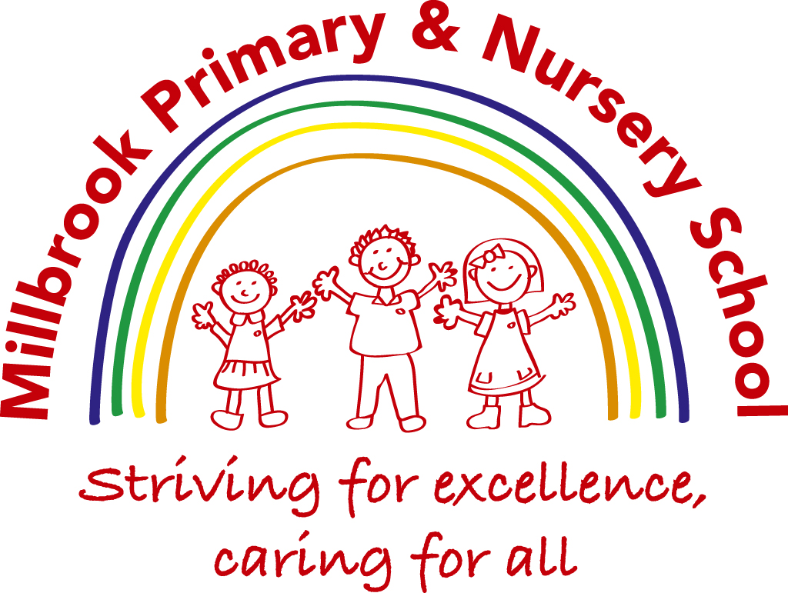

EYFS Policy

The Governing body has overall responsibility of ensuring that the EYFS, as written does not discriminate on any grounds, including but not limited to: ethnicity/national origin, culture, religion, gender, disability, or sexual orientation.
Equality Objectives Statement
Our equality objectives are:
- To promote spiritual, moral, social and cultural development through all appropriate curricular and extra-curricular opportunities. We aim to meet this objective with reference to issues of equality and diversity.
- To reduce prejudice and increase understanding of equality through direct teaching across the curriculum.
- To move beyond deterministic notions of fixed ability and to model teaching and learning behaviours that avoid labelling.
- To narrow the gap in attainment in all subjects between different groups (boys and girls, pupil premium and non pupil premium).
- To promote cultural development and understanding through a rich range of experience, both in and beyond the school.
- To eradicate prejudice related bullying in relation to the protected characteristics listed in the Equality Act 2010.
- To tackle prejudice and promote understanding in relation to people with disabilities
Aim
Early childhood is the foundation on which children build the rest of their lives. At Millbrook Primary School, we greatly value the important role that the Early Years Foundation Stage (EYFS) plays in laying secure foundations for future learning and development. It is important to view the EYFS as preparation for life and not simply preparation for the next stage of education.

The EYFS is for children from birth to five years of age. The final year of the EYFS is referred to as the reception year. All children begin school with a variety of experiences and learning.

It is the privilege of the practitioners working in Foundation Stage to take on the task of building upon that prior learning and experience. Foundation Stage team work effectively together to support children's learning and development.

This document outlines the philosophy, aims and principles of early years teaching and learning in the Foundation Stage at Millbrook Primary School. The document underpins practice in all areas of provision.

Early Years Foundation Stage
Every child deserves the best possible start in life and the support that enables them to fulfil their potential. Children develop quickly in the early years and a child’s experiences between birth and age five have a major impact on their future life chances. A secure, safe and happy childhood is important in its own right. Good parenting and high-quality early learning together provide the foundation children need to make the most of their abilities and talents as they grow up.

The Early Years Foundation Stage (EYFS) sets the standards that all Early Years providers must meet to ensure that children learn and develop well and are kept healthy and safe. It promotes teaching and learning to ensure children’s ‘school readiness’ and gives children the broad range of knowledge and skills that provide the right foundation for good future progress through school and life.” (DFE, Statutory Framework for the early years and foundation stage, 2021, Statutory framework for the early years foundation stage (publishing.service.gov.uk))

We pride ourselves in considering ‘the whole child’ and recognise that their learning journey is not just one of academia, but a social and emotional adventure too. We want our children to be happy, confident and resilient individuals who challenge themselves and care for people within their setting and the wider community.

In line with the changes in 2021 the early years team are developing a fit-for-purpose and developmentally appropriate curriculum design that ensures that pupils are supported in their next steps of progression based on four principles:

A Unique Child
Positive Relationships
Enabling Environments
Learning and Development

The Unique Child
At Millbrook Primary School we recognise that every child is a competent learner who
can be resilient, capable, confident and self‐assured. We recognise that children develop in individual ways, at varying rates. Children’s attitudes and dispositions to learning are influenced by feedback from others; we use praise and encouragement, as well as celebration and rewards, to encourage children to develop a positive attitude to learning.

Positive Relationships
At Millbrook Primary School we recognise that children learn to be independent confident learners from secure relationships with their peers and adults. We aim to develop caring, respectful, professional relationships with the children and their families. Parent/school partnerships are of utmost importance to staff. EYFS staff are available to speak to should parents have any concerns. We equally want to celebrate success and ask parents to share this with staff to ensure children receive the recognition they deserve.

Enabling Environments
Additionally, we believe that the environment plays a key role in supporting and extending the children’s development. Through observation, we assess the children’s interests, stages of development and learning needs, before planning challenging, achievable activities and experiences to extend the children’s learning.
We also plan and consider the Learning Environment. The Foundation Stage Classrooms are organised to allow children to explore and learn securely and safely. There are areas where the children can be active, be quiet and rest. The Reception and Nursery classes are set up in learning areas, where children are able to find and locate equipment and resources independently.

Learning and Development
The early learning goals and the educational programmes are set out in the “Statutory
Framework for the Early Years Foundation Stage” document (DFE, 2021).
The seven areas of learning and development are:

Prime:
- Personal, Social and Emotional Development (PSED)
- Communication and Language (CL)
- Physical Development (PD)
Specific:
- Mathematics (M)
- Literacy (L)
- Understanding of the World (UW)
- Expressive Arts and Design (EAD)

At Millbrook Primary School we believe that once the children are secure in the Prime areas of learning they will be prepared to access the specific areas. However, all areas are important to ensure the development of the ‘whole child’. We aim to deliver all the areas through planned, purposeful play, with a balance of adult‐led and child-initiated activities.

Observation, Assessment and Planning
Planning
Objective-led planning is the key to making children’s learning effective, exciting, varied and progressive. Effective learning builds on and extends what children know and can already do. Our reflective approach promotes independence and self-motivation in delivering individualised curricula to our pupils. This contributes to our evaluation of their progress toward their Early Learning Goals.

Our planning is responsive to the children’s daily interests and learning needs, demonstrating the principles of the EYFS. All practitioners who work in the Foundation Stage at Millbrook Primary School are involved in informing the next steps.

In our planning, we address the needs of the children both in terms of their individual
development as well as their needs as a cohort. We employ the three characteristics of
effective teaching and learning in our planning: playing and exploring (Engage), active learning (process), and creating and thinking critically (challenge).

Learning is planned and purposeful with a mixture of child-initiated and teacher-initiated activities. The seven areas are delivered through planned, purposeful play, incorporating a balance of adult and child-led activities, supported by class-based, age-appropriate, formalised learning, which it would deepen and extend learning to adopt this approach. We assess and record children’s independent learning and set individualised next steps to support them in achieving their Early Learning Goals.

During focused activities, teaching staff develop children’s vocabulary by using a range of strategies. Staff identify the level of support needed or if the work was done independently. Children are encouraged to discuss their work using talk partners and next steps are discussed with the children in friendly terms. Challenges are incorporated into the continuous provision so that children can apply what they have learnt in the focused activity session. Staff model and scaffold children’s learning so they can apply their skills and knowledge independently through play.
Information collated over the year from Reception baseline, Evidence Me assessments, observations of the children, and teacher knowledge provides the evidence base for the Early Learning Goals at the end of Reception.

Resources
We plan a learning environment, both indoors and outdoors, that encourages a positive attitude towards learning. We use materials and equipment that reflect both the community the children come from and the wider world. Children are generally encouraged to make their own selection of the activities on offer, as we believe this supports independent learning. Our continuous provision is designed to help the child learn and master many areas of learning such as practical life, sensorial, maths, language and culture. We have a strong awareness of the role which technology plays in modern life and this is reflected in our classroom practice.

Assessment
We utilise our assessments in a range of ways, including individual and cohort analysis of progress and areas for development, as well as to help plan activities and support. We endeavour to make all assessment procedures as efficient as possible, so as not to distract practitioners from their interaction with their pupils. A statutory baseline assessment takes place within the first 6 weeks of the academic year.
In the Early Years Foundation Stage (EYFS), assessment is an integral and continuous part of the teaching and learning process. Our setting uses Evidence Me as a key assessment tool to support holistic observations and inform both formative and summative assessments. Practitioners regularly capture a wide range of observations across all areas of learning and development, ensuring that each child’s interests, progress, and next steps are accurately documented. Evidence Me enables staff to reflect on each child’s journey, celebrate achievements, and tailor learning experiences accordingly. This approach ensures a well-rounded understanding of every child’s needs and development, promoting high-quality, responsive teaching and supporting effective communication with parents and carers. Half-termly observations support evidence of the children’s progress, and observations are monitored and moderated by the EYFS lead. These observations are used to inform the end of Foundation Stage assessment against the Early Learning Goals and the Characteristics of effective learning (2021) Statutory framework for the early years foundation stage (publishing.service.gov.uk)

In EYFS, we use Padlet for the children’s next steps, which informs planning and resourcing for the continuous provision areas both indoors and outdoors. Next steps focus on children’s knowledge and skills they need to acquire developmentally.

At the end of the EYFS, all children are assessed using the Early Years Foundation Stage Profile which rates their progress towards their Early Learning Goals with one of the following standards; emerging or expected. Where children have special educational needs, reasonable adjustments are made to the assessment process. For more information, please see EYFS assessment procedures.

Parents/carers are given a copy of their child’s progress with a comprehensive report detailing their progress in all seven areas of the curriculum about the characteristics of effective learning. The Leuven scales are also discussed with parents throughout the year. Parents are given the opportunity to meet with their child’s class teacher to discuss their child’s progress. We send a summary of these assessments to the Local Authority for analysis and take part in moderation activities at our local authority.

Food & Drink:
Children are provided with healthy, balanced and nutritious meals, snacks and drinks. We work with parents to obtain information about each child’s dietary requirements, preferences and food allergies as well as any health requirements they may have. We provide the children with fresh drinking water at all times and act on information from carers regarding children’s dietary needs. We have a suitable area for the hygienic preparation of food for children. Staff who prepare and handle food are trained to do so.

Accident or Injury:
First aid boxes are kept in each classroom and separate ones are taken on off-site visits. Where an accident takes place whilst the child is in the care of the school, the member of staff dealing with the incident initially treats the child, ensuring that they are then made as comfortable as possible. Following this, staff members will complete relevant accident forms in line with our First Aid policy and procedure and ensure the incident is reported to the parents of the child. In the case of a severe accident, appropriate action will be taken first, and any relevant paperwork completed aftercare has been delivered. Sun protection: When weather conditions dictate, we request that parents send their child to school with appropriate sun cream. Where we identify that a child is at risk, staff members will take appropriate action to safeguard them.

Managing Behaviour:
We are aware that we are responsible for managing the behaviour of the children in our care. We select appropriate means by which to reinforce positive and, where necessary, sanction negative behaviour. We adopt a conflict resolution approach where children are allowed to reflect upon their behaviour. Please see our behaviour policy. The staff promote the rainbow reflection and a time out/reflection process to encourage the emotional intelligence aspects of learning in the EYFS.

Staffing and Organisation
At Millbrook Primary School, we have one reception class that typically admits up to 30 children per class. There is currently 1 class teacher and 1 teaching assistant, with extra staff carrying out intervention work and personal care. The classroom is based in one room which is separated into areas to support the children in accessing the curriculum at an appropriate level to match their ability, as well as providing challenge and inspiration. Nursery consists of 2 sessions 8.45-11.45 and 12.30-3.30 with 26 places in each. There is 1 class teacher and 2 teaching assistants.

There are also two doors leading to our outdoor provision. Children have access to the outdoors throughout the whole day, during child-initiated time. The EYFS Lead Emma Rawson.

Learning through play
“Play is essential for children’s development, building their confidence as they learn to
explore, to think about problems, and relate to others. Children learn by leading their own play, and by taking part in play which is guided by adults.” (“Early Years Foundation Stage”, DFE, 2021 Statutory framework for the early years foundation stage (publishing.service.gov.uk))
At Millbrook Primary School we support children’s learning through planned play
activities and decide when child‐initiated or adult‐led play activities would provide the most effective learning opportunities. We believe that it is important for adults to support children’s learning through play, by getting involved in the play themselves and modelling by example.

Planning is objective-led and targeted for Reading, Writing and Maths. Observation of the children’s progress and attainment is recorded daily during focused sessions for the specific areas. Class floor books highlight key achievements for the children throughout the year. Photographs of key events in the Nursery and Reception and exemplary pieces of work, mainly done independently by the children, are included in this book. The class floor book is a large book for recording children's learning, individually and collaboratively. Floor books are used as a strategy for developing and assessing children's understanding of the learning that has taken place and are used as part of reflection time. Floor books are a shared document and hence invites collaboration and exchange of ideas.

Induction to Nursery
Children can attend Millbrook Nursery the term after they are 3 (if numbers allow). The EYFS lead and class teacher will carry out home visits prior to their start date. The children will also attend a morning or afternoon visit to the setting where they can familiarise themselves with staff and the environment.

The number of 30-hour funded places are considered on a cohort basis. Qualifying parents are to provide a packed lunch for their child; the school day will begin at 8.45 am and children are available for collection from 3.30 pm. The children are supervised by two members of staff in the nursery area during the lunchtime period.

Induction to Reception
During the summer term, nursery children who will be starting school in September make more frequent visits to the reception class as part of the transition process.

Parents/guardians have the opportunity to meet the class teacher and to visit the reception classroom at a ‘New Parent ‘meeting. The foundation stage leader and class teacher to introduce parents/guardians to the school and reception procedures. Through this meeting, the school’s expectations and routines are communicated as well as ways in which staff can help their child.

There is a formal transition day in line with the whole school where children from other nursery settings who have been allocated a place at Millbrook, will be invited to attend. Parents/guardians are given a pack which outlines the reception curriculum and school routines, along with other necessary documentation. Transfer records from preschool settings inform reception practitioners about the new intake. Where possible, visits to other local pre‐school settings are made in order to aid the induction process further. Children start full-time in line with the rest of the school.

The aims of this transition are to:
● Allow the children to adjust and feel secure in their new environment
● Allow the practitioners to get to know the children individually and establish good
relationships
● Allow the reception teacher to carry out initial assessments

Reception to Year 1 Transition
Reception and year 1 teachers have worked together to make the transition from the Early Years Foundation Stage to Key Stage 1 as smooth as possible.

At Millbrook Primary School:
● Children are encouraged to develop independence when dressing and undressing and
when organising their personal belongings throughout the reception year.
● Reception practitioners plan longer more structured activities to be undertaken during the summer term; encouraging less dependence on adult support.
● Reception children meet year 1 teachers during assemblies and other whole school
activities during the reception year.
● End of Year assessments against the Early Learning Goals and the characteristics of
effective learning are shared and discussed.
● Reception and year 1 teachers meet to discuss the individual needs of children in July.
● Reception children visit their new year 1 class and teacher for a morning on transition day in July.
● The Year 1 classroom includes learning areas similar to the reception classrooms

Home/School Links
We recognise that parents/guardians are the child’s first and most enduring educators.
When parents/guardians and practitioners work together in early years settings, the results have a positive impact on the child’s development. A successful partnership needs to be a two‐way flow of information, knowledge and expertise.

We aim to develop this by:
● Outlining the school’s expectations to parents/guardians during the new parents’ workshops in September.
● We hold further curriculum workshops to guide parents in supporting their child’s learning at home.
● Holding parent/guardian class visits for different topic s and celebrations
● Operating an “open door” policy, whereby parents/guardians can come and discuss
concerns and developments in an informal manner.
● Encouraging parents/guardians to listen to their child read each night and to comment on reading progress on Wow Cards
● Discussing children’s individual targets with parents/guardians parents’ evenings three times a year.

Information for Parents and Carers:
Parents can access a range of information about the setting via our Parent Information booklet, the website, Dojo, newsletters and other distributions from the school. We inform our parents of how the EYFS is being delivered in the setting, and how parents and/or carers can access more information, the range and type of activities and experiences provided for children, the daily routines of the setting, and how parents and carers can share learning at home, how the setting supports children with special educational needs and disabilities, food and drinks provided for children, details of the provider's policies and procedures (we also make copies available on request) including the procedure to be followed in the event of a parent and/or carer failing to collect a child at the appointed time, or in the event of a child going missing at, or away from, the setting; staffing in the setting, the name of their child’s key person and their role and a telephone number for parents and/or carers to contact in an emergency.

Safeguarding
We take all necessary steps to ensure that our children are safe and well as we recognise that children who are healthy, safe and secure in the broadest sense have the best chance at fulfilling their potential in all areas, both at home and at school. In line with statutory regulations, and following best practices, we adhere to our school’s Safeguarding Policy.

Characteristics of Effective Learning
In the Early Years Foundation Stage we believe that play based learning is one of the best opportunities for children to develop all the characteristics of effective learning – to be actively involved and motivated in their activities, as well as to think creatively and critically.
In planning and guiding children’s activities, practitioners must reflect on the different ways that children learn and reflect these in their practice. Three characteristics of effective teaching and learning are:
- Playing and exploring – children investigate and experience things and ‘have a go’
- Active learning – children concentrate and keep on trying if they encounter difficulties, and enjoy achievements; and
- Creating and thinking critically – children have and develop their own ideas, make links between ideas, and develop strategies for doing things.

It is important, particularly in child initiated play that practitioners effectively promote the characteristics described above.
The learning environment is well organised both indoors and outdoors and Practitioners provide a balance of structured/focussed and child-initiated play activities.
Practitioners work alongside the children, using their knowledge of each individual child, to intervene, when necessary, to support or move learning on to the next step, therefore, extending the child’s knowledge.
Practitioners are also role- models for demonstrating play and developing positive relationships between the children, where sharing and turn-taking is encouraged and vocabulary is extended.
Forest School
All children in Nursery and Reception will take part in a weekly Forest School session.
At Millbrook Primary School we believe that Forest School is an inspirational process that offers children opportunities to achieve and develop confidence and self-esteem through play and hands-on learning experiences, in a woodland environment.

By producing and adopting this policy for Forest School and outdoor learning, Millbrook Primary School aims to give all children and practitioners a collective insight into the ethos of Forest School.
Forest School builds on a child’s innate motivation and positive attitude to learning, offering them the opportunities to increase their self-reliance/independence, take risks in a well-managed, safe environment, make their own choices and initiate learning for themselves.

The Forest School and outdoor learning environment provide opportunities for children to develop self-esteem, and self-confidence and encourage independence. It helps children to form positive relationships with others, develop a growing awareness of their emotional needs and the needs of others, learn to cooperate and work with their peers and adults and develop strategies in order to take risks within the boundaries of safety. At Forest School, nobody fails. Forest School is about exploring and experiencing the natural world and has a significant impact on children’s creative and spiritual development. At Millbrook, we believe it is a very powerful way of helping children to appreciate the spiritual dimension of their locality and allows them to learn how to become creative within it. This is achieved through practical activities using natural objects that they find and opportunities to stop and wonder at the world around them.

The children will go out in all weathers, all year round, exploring and learning from the seasons and environmental changes. The children’s interests along with the varied natural resources in our school grounds and woodland are used to stimulate creative thinking, problem solving and skill development, all in the guise of play.

Inclusion
We value the diversity of all individuals within the EYFS and do not discriminate against children because of differences. All children at Millbrook Primary and Nursery School are treated fairly regardless of race, religion or level of ability and are listened to and respected. We promote positive attitudes to diversity and difference and all children and their families are included and valued.
In our school, we believe that all children matter. We ensure our children have every opportunity to achieve and do this by taking account of our children’s range of life experiences and planning for their learning requirements. We set realistic and challenging expectations that meet the needs of all children within our setting. We achieve this by planning to meet the needs of all, children with special educational needs, children who are more able, children with disabilities, children from all social and cultural backgrounds, children of different ethnic groups and those from diverse linguistic backgrounds, socially excluded families or traveller communities. (For additional information please refer to the Equal Opportunities Policy)
We aim to-
- respond to children’s early needs for additional support and call in specialist help from outside agencies when needed
- overcome barriers for children where they may already exist
- counter underachievement
- Work with the PLA to help create good home/school relationships
We meet these needs through-
- planning opportunities that build upon and extend children’s knowledge, experience and interests, and develop their self-esteem and confidence
- Using a wide range of opportunities to motivate and support children
- Providing a safe and supportive learning environment in which the contribution of all children is valued
- Support children to develop positive relationships with adults and children in the setting
- Use resources which reflect diversity and are free from stereotyping and discrimination
- Planning challenging activities for children whose ability and understanding are in advanced
- Monitoring children’s progress and preparing individual education plans for those children who need support

Additional Welfare notes
- Classroom and the outside area are carried out under the whole school risk assessment procedures
- All adults who will be working with children unsupervised will need to be DBS-checked
- If an adult is concerned about a child’s welfare they can refer to the school's Safeguarding Children policy and follow the appropriate guidelines.
- All staff preparing food e.g. snacks or as part of a baking or tasting activity will have a basic food hygiene certificate
- At least one member of staff in each EYFS classroom will have received training on Paediatric First Aid. The first aid box is regularly checked and kept full. All accidents and actions taken are recorded in a first aid book and parents/carers are notified of this.
- A parent/carer log is kept recording any incidents or concerns about a child’s welfare. This information is passed on to the head teacher and any other agencies that need to be involved.

EAL
We hold a current EAL register which is updated annually. Across the EYFS, there is a
a low percentage of children for whom English is an additional language, though many different languages are represented. Our annual cohort composition determines what extra facilities and activities we will incorporate into our classrooms and environments.

We aim to provide opportunities for children to share their home language in play and learning. We work to ensure that children have sufficient opportunities to learn and reach a good standard in English during the EYFS. Where needed we will also provide an interpreter to facilitate parent meetings and any opportunity that affords communication regarding a child’s progress or any safeguarding issues that should arise.

Date: Reviewed
By Emma Rawson
EYFS LEAD
September 2025

